SCHOOL OF ENGINEERING
PROJECT WEEKLY PROGRESS REPORT
Name : Lee Dong Geon | Admin No :  242558W | Module Code : | Week No :  2 | Date of Monday :  16/3/2026
Objectives of the Week :

The main objective for this week was to improve the resume screening system by working on the preprocessing part and adding multiple LLM APIs for evaluating candidates. At this stage, the focus was not just on getting the code to run, but also organizing the workflow so that both the resumes and job description could be processed consistently before being sent to the models.

Another objective was to test out different LLMs and see how they score the same candidate using the same job description.

For Week 3, the objective was to implement RAG using LangChain. It was to improve the screening process by only retrieving relevant parts of each resume instead of sending the entire text to the LLM. This helps make the evaluation more focused and efficient and also makes sure that the job requirements and the results are aligned.

Objectives Achieved and Work Done :

During this period, I was able to make good progress on both the main pipeline and the RAG version of the system. First, I completed the text preprocessing stage by cleaning the raw resume and job description text so that the inputs going into the models were more standardised. This reduced noise and made everything consistent.

After that, I put different LLM APIs into the workflow and created separate response functions for each one. From the notebook, I tested Gemini, Cohere, Groq, Hugging Face, and OpenRouter, and structured the code so that I could pass resumes through each model in a consistent way.

A major improvement in Week 3 was adding RAG using LangChain. I converted the cleaned resumes into LangChain Document objects and split them into smaller chunks using a text splitter, so the system could analyse some sections instead of just the full document. Then, I used a Hugging Face vector representation model to convert these chunks into vectors and stored them in a FAISS vector store. The system would retrieve the relevant parts of the resume based on the job description before sending it to the LLM.

I also created a RAG based prompt where the model evaluates candidates using only the retrieved sections instead of the entire resume. The evaluation would be more focused and the model would focus on the relevant skills. On top of that, I compared the results between RAG and non-RAG approaches, which showed that I was not just adding features, but also checking whether the improvement made a difference.

Overall, the work that I have done on week 2-3 turned the basic screening system to a more structured and advanced pipeline. The results were easier to compare, and adding LangChain and RAG improved the overall effectiveness of the system in matching candidates to the job requirements.

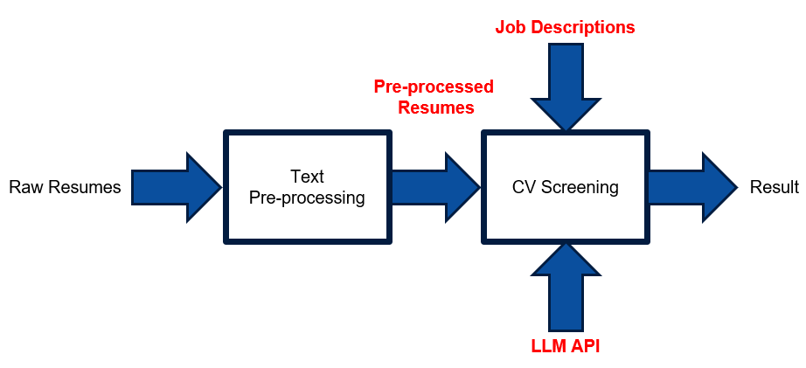

Supervisor’s Comment :

_____________________
Date/Signature

